APPROVAL SHEET

MODEL NO.：

CUSTOMER：

CUSTOMER'S APPROVAL：

AUTHORIZED SIGNATURE/STAMP DATE

MANUFACTURER:
The Fourth Industrial Zone,Luokeng Village, Xiaotie District, Xiaojinkou Town, Huizhou City, Guangdong Province, China
Tel: 0752-7213069/7213070
Fax: 0752-7213065

Submitted by:
Approved by:
Date:

Performance Specification

Model |  |  |  |  |  | Maximum |  | Resistance
Model | V _{max} | I_{max} | I _{hold} | I _{trip} | P_{d} | Time To Trip
Model |  |  | @25°C | @25°C | Typ. | Current | Time | R i _{min} | R1max
Model | (V dc) | (A) | (A) | (A) | (W) | (A) | (Sec) | (Ω) | (Ω)
SMD0402R004SF | 12.0 | 40 | 0.04 | 0.16 | 0.5 | 0.25 | 1.50 | 3.00 | 30.0
SMD0402R005SF | 9.0 | 40 | 0.05 | 0.20 | 0.5 | 0.25 | 1.50 | 1.50 | 20.0
SMD0402R0075SF | 9.0 | 40 | 0.075 | 0.20 | 0.5 | 0.25 | 1.50 | 1.20 | 10.0
SMD0402R009SF | 6.0 | 40 | 0.09 | 0.18 | 0.5 | 0.50 | 1.00 | 0.15 | 4.0
SMD0402R010SF | 6.0 | 40 | 0.10 | 0.30 | 0.5 | 0.50 | 1.00 | 0.15 | 2.800
SMD0402R018SF | 6.0 | 40 | 0.18 | 0.48 | 0.5 | 1.00 | 1.00 | 0.12 | 2.600
SMD0402R020SF | 6.0 | 40 | 0.20 | 0.50 | 0.5 | 1.00 | 1.00 | 0.10 | 1.800

V max = Maximum operating voltage device can withstand without damage at rated current (Imax).
I max = Maximum fault current device can withstand without damage at rated voltage (V max).
I hold = Hold Current. Maximum current device will not trip in 25°C still air.
I trip = Trip Current. Minimum current at which the device will always trip in 25°C still air.
Pd = Power dissipation when device is in the tripped state in 25°C still air environment at rated voltage.
Ri min/max = Minimum/Maximum device resistance prior to tripping at 25°C.
R1max = Maximum device resistance is measured one hour post reflow.
CAUTION : Operation beyond the specified ratings may result in damage and possible arcing and flame.

Environmental Specifications
Test |  |  |  | 條件
Passive aging |  |  |  | +85°C, 1000 hrs.
Thermal shock |  |  |  | +85°C to -40°C,
Resistance to solvent |  |  |  | MIL-STD-202,Method 215 |  |  |  | 电阻不變化
Vibration |  |  |  | MIL-STD-202,Method 201 |  |  |  | 电阻不變化
操作條件環境： - 40 °C~+85°C
在跳閘狀態下產品的表面最高溫度為125°C

Agency Approval and Environmental Complianc
Agency | File Number |  | Regulation | Standard
UL | pending |  |  | 2011/65/EU
TUV | pending |  |  | EN14582

Thermal Derading Chart
Recommended Hold Current(A) at Ambient Temperature(°C)

Model | Ambient Operation Temperature
Model | -40°C | -20°C | 0°C | 25°C | 40°C | 50°C | 60°C | 70°C | 85°C
SMD0402R004SF | 0.056 | 0.05 | 0.045 | 0.04 | 0.034 | 0.026 | 0.02 | 0.016 | 0.013
SMD0402R005SF | 0.073 | 0.065 | 0.058 | 0.05 | 0.044 | 0.04 | 0.037 | 0.033 | 0.028
SMD0402R0075SF | 0.11 | 0.105 | 0.090 | 0.075 | 0.065 | 0.06 | 0.055 | 0.045 | 0.035
SMD0402R009SF | 0.13 | 0.115 | 0.010 | 0.09 | 0.075 | 0.07 | 0.06 | 0.05 | 0.04
SMD0402R010SF | 0.14 | 0.13 | 0.11 | 0.10 | 0.09 | 0.08 | 0.07 | 0.06 | 0.05
SMD0402R018SF | 0.32 | 0.28 | 0.20 | 0.18 | 0.16 | 0.14 | 0.13 | 0.12 | 0.10
SMD0402R020SF | 0.29 | 0.26 | 0.23 | 0.20 | 0.18 | 0.16 | 0.15 | 0.13 | 0.09

Thermal Derating Curve 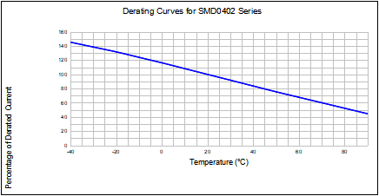
Average Time-Current Curve
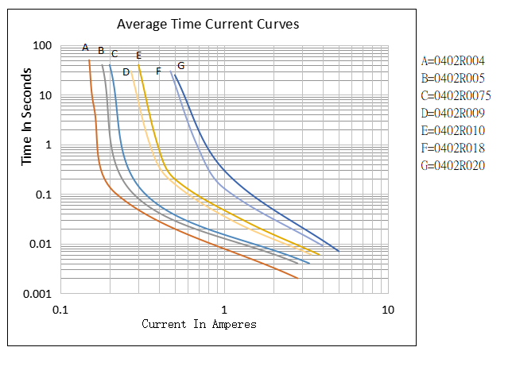

Soldering Parameters
t L
60~150 s
ts
Preheat 60~180 s
t 25°C to peak
Time
Temperature(°C)
TL 217
TP 260
25
TP 20~40 S
Ramp-up
Critical Zone
TL to TP
Ramp-down
Tsmax
Tsmin
150
200
Profile Feature | Pb-Free Assembly
Average Ramp-Up Rate(Ts max to T p) | 3℃/second mac.
Preheat  -Temperature Min(Ts min)  -Temperature Max(Ts max)  -Time(Ts min to Ts max) | 150℃  200℃  60~180 seconds
Time maintained above:  -Temperature(TL)  -Time(tL) | 217℃  60~150 seconds
Peak Temperature(Tp) | 260℃
Ramp-Down Rate | 6℃/second max.
Time 25℃ to Peak Temperature | 8 minutes max
Storage Condition | 遮光密封
Recommended reflow methods: IR, vapor phase oven, hot air oven, N2 environment for lead-free
Recommended maximum paste thickness is 0.25mm
Devices can be cleaned using standard industry methods and solvents.
Note 1:All temperature refer to topside of the package, measured on the package body surface.
Note 2: If reflow temperatures exceed the recommended profile, devices may not meet the performance requirements

Physical Dimensions(mm.)
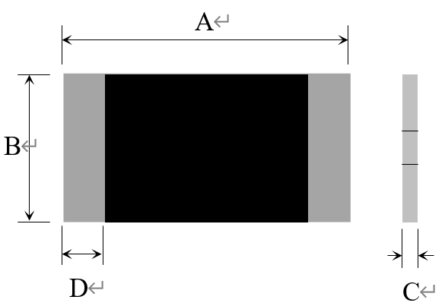
型號 | A |  | B |  | C |  | D
型號 | Min. | Max. | Min. | Max. | Min. | Max. | Min.
SMD0402R004SF | 0.85 | 1.15 | 0.35 | 0.65 | 0.4 | 0.8 | 0.10
SMD0402R005SF | 0.85 | 1.15 | 0.35 | 0.65 | 0.4 | 0.8 | 0.10
SMD0402R0075SF | 0.85 | 1.15 | 0.35 | 0.65 | 0.4 | 1.0 | 0.10
SMD0402R009SF | 0.85 | 1.15 | 0.35 | 0.65 | 0.4 | 1.0 | 0.10
SMD0402R010SF | 0.85 | 1.15 | 0.35 | 0.65 | 0.4 | 1.0 | 0.10
SMD0402R018SF | 0.85 | 1.15 | 0.35 | 0.65 | 0.4 | 1.0 | 0.10
SMD0402R020SF | 0.85 | 1.15 | 0.35 | 0.65 | 0.4 | 1.0 | 0.10

Termination Pad Characteristics
Terminal pad materials：Tin-plated Nickel-Copper
Terminal pad solder ability：Meets EIA specification RS186-9E and ANSI/J-STD-002 Category 3.

Recommended Pad Layout (mm.)
0.5士0.1
0.435士0.1
0.435士0.1
0.6士0.1
注：在此印锡面积条件下，推荐钢网厚度为≧0.12MM(钢网厚度不够要增大刷锡面积）

Packaging Quantity
Part Number | Quantity
SMD0402HF Series | 10,000 pcs/reel
Tape & reel packaging per EIA481-1

Tape And Reel Specifications (mm)
P1
W
E2
F
E1
P0
P2
B0
K0
B1
T1
Cover tape
D0
A0
Embossment
T
EIA Tape Component Dimensions
Governing Specifications |  | EIA 481-1
W |  | 8.0 ± 0.2
P₀ |  | 4.0 ± 0.10
P₁ |  | 4.0 ± 0.10
P₂ |  | 2.0 ± 0.05
A₀ |  | 0.65 ± 0.10
B₀ |  | 1.15 ± 0.10
D₀ |  | 1.55 + 0.05
F |  | 3.5 ± 0.05
E₁ |  | 1.75 ± 0.10
E₂min. |  | 6.25
T |  | 0.20
T₁max. |  | 0.1
K₀ |  | 0.60/0.75 ± 0.1
Leader min. |  | 390
Trailer min. |  | 160
卷軸規格
A max. |  | 178
N min. |  | 60
W₁ |  | 9.0 ± 0.5
W₂ |  | 12.0 ± 0.05
W |  | 8.0 ± 0.2
Storage And Handling
‧ Storage conditions：遮光密封
‧ Devices may not meet specified performance
if storage conditions are exceeded.

Embossed cavity
Cover tape
Carrier tape
A
W2(measured at hub)
N(hub dia.)
W1(measured at hub)
2
2
2
0
EIA Reel Dimensions

Part Number System
SMD 0402 R 口口口 S F 口口V
special voltage Rating(Optional)
Lead-Free
Tin-plated Nickel-Copper
Holding Current Rating
Da Rong
Device Dimensions: Length/width(Unit:1/100 inch) Size1608mm / 0603 inch
Surface Mount Device

注意事项
PPTC使用注意事项：
·PPTC为热敏元件，对环境温度比较敏感，建议在PPTC周围不要设计热源元件，环境温度最高控制在85℃，尽量减少外部热源的影响，否则会影响产品性能导致焊后电阻大于规格。
·请在规格书规定的参数下(<10%)使用，超出电压电流规格值，会导致PPTC出现电弧，阻值升高，甚至烧片。
·规格书的电气特性，均是基于在大容指定测试板经过一次回流焊之后的测试；如果客户有二次回流焊或者注塑点胶等其他热工序，会对上述参数有一定程度的衰减，需要验证其适用性。
. PPTC设备在故障状态下会发生热膨胀。如果PPTC装置安装或放置在PPTC装置与周围材料（如覆盖材料、包装材料、封装材料等）之间的空间不足的应用中，将对热膨胀产生抑制作用。挤压、扭曲、弯曲和其他类型的机械应力也会对PPTC设备的性能产生不利影响，不得使用或施加。
·PPTC贴片产品是为SMT工艺设计的封装形式，焊接工艺为回流焊；要求客户遵守我们推荐的焊盘布局和回流焊配置文件。不正确的电路板布局或回流配置可能会对PPTC的可焊性性能产生负面影响。焊接工艺可参考大容推荐的回流焊曲线。如果回流焊温度超过推荐的值，PPTC将有可能受到损伤。使用手工焊及波峰焊接PPTC可能会导致产品焊后电阻超出规格。
·某些注塑料、单组份、双组份固化胶粘剂、硅胶、特种润滑理基脂、侵蚀性溶剂、石蜡污染PPTC材料破坏芯片，需要对注塑料胶料、石蜡等材料牌号以及应用参数（如温度、时间等）进行验证，以确保产品及工艺的匹配性，确认不会影响PPTC性能之后方可使用。PPTC在充电线端应用中，建议使用PP类材料做内膜，禁止使用TPE类与PVC类等材料做内膜。
·PPTC贴装或使用过程中，不建议使用洗板水或其他清洗剂进行清洗。如必须使用，需要验证各类清洗剂、洗板水以及溶剂的适用性，确认不会影响PPTC性能之后方可使用。已知对PPTC有影响的化学药品包括但不仅限于醚类、苯类、酮类以及脂类等较强溶解性、破坏性的有机化合物，清洗后将产品放置于敞开的环境中至少24小时，将残留的溶剂进行充分的挥发。
·装配过程中，避免用暴力砸、挤、压、拉、扭、刺等方式作用PPTC本体，以免引起PPTC 性能衰减。
·PPTC元件是为电路中偶尔出现的过流而设计的，不建议用在连续且持续过流、重复故障的电路中（此类故障情况可能是由连接器的错误引脚连接引起的），或过大范围跳闸事件可能发生时，不得使用。
·大容SMD PPTC产品为遮光密封包装。客户如在库存中发现有包装破损的，立即将产品隔离处理；使用时如有余料，需恢复之前包装状态，做遮光密封保存，否则会影响产品性能导致焊后电阻大于规格。
·产品废弃时，可按照一般电子废弃物处理，具体材料组成可参见MSDS

如果以上注意事项的任何项目未得到遵守，则免除所有的责任。

